Adam Paster, Floridon Gjongecaj

EECE – 321 Embedded Systems

Dr. Ahmed Hussein

**Lab #1: Blinking LED**

**INTRODUCTION**

The goal of this lab was to familiarize us with the basics of Programmable System on Chip Creator IDE (Integrated Development Environment) through executing a blinking LED regulated by the software. In the new project file, the LED pin is assigned, components are positioned and connected, and firmware is written to manipulate the function(s) of the LED. Once the project is built and debugged, it is programmed onto the BLE kit and we observed in hopes of a hypothesized outcome.

The first objective we were given was to turn the LED on and assign it a blue color via the pin assignment. We achieved this through simply assigning the LED Pin to the correct RGB pin-out, which for this case was P3[7] in order to get the blue, to the Digital Output Pin. We had to disable the Hardware Connection to allow the firmware to take control.

Blue LED

**Additional Exercises**

1. Green LED



Changing the color of the flashing LED was quite simple, an adjustment to the pin assignment was the only necessary step, from P3[7] to P3[6].

2. Constant White LED

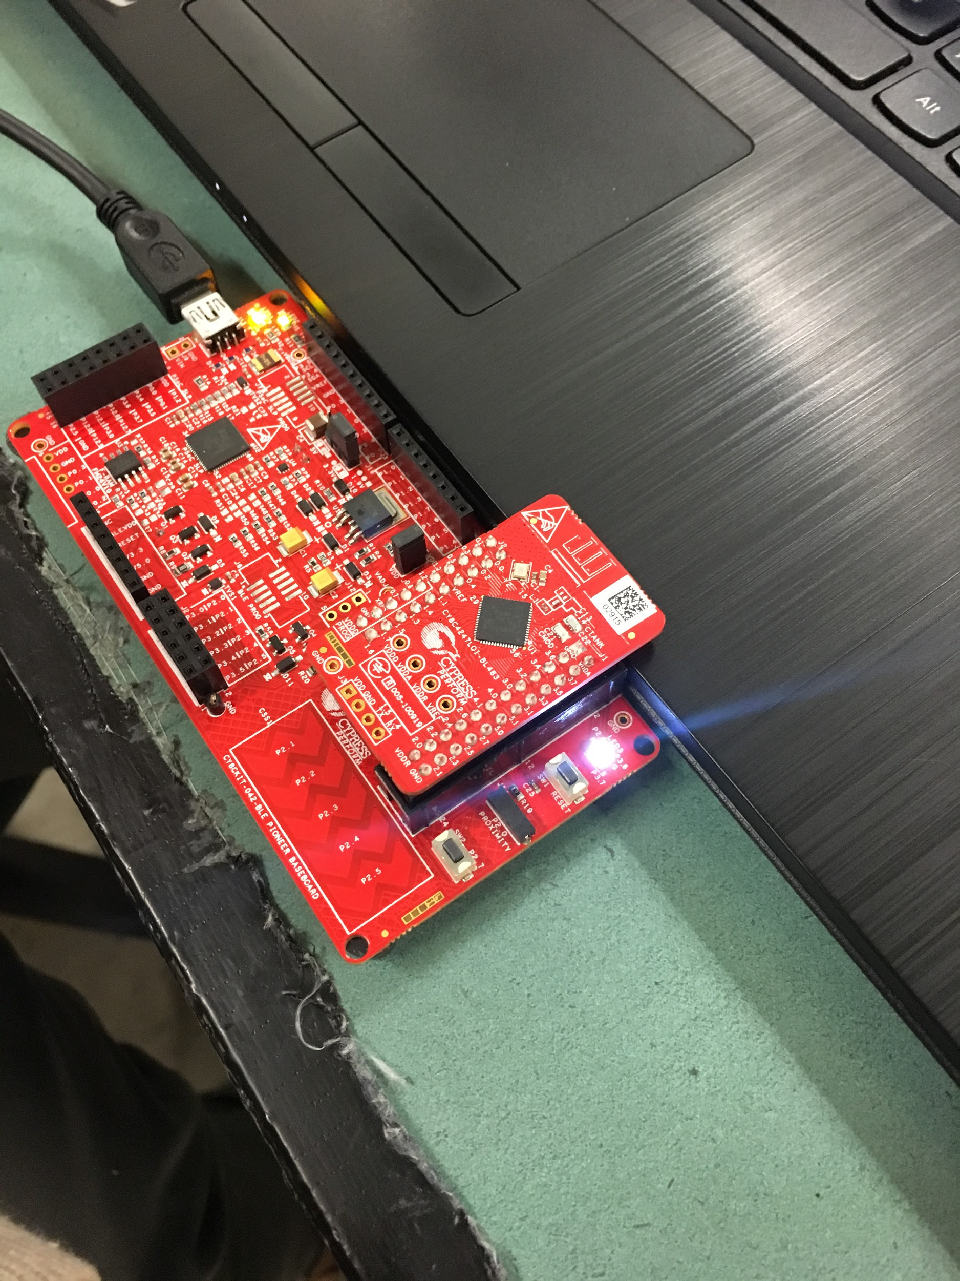

(Code for Project 1 Question 2: Constant White LED)

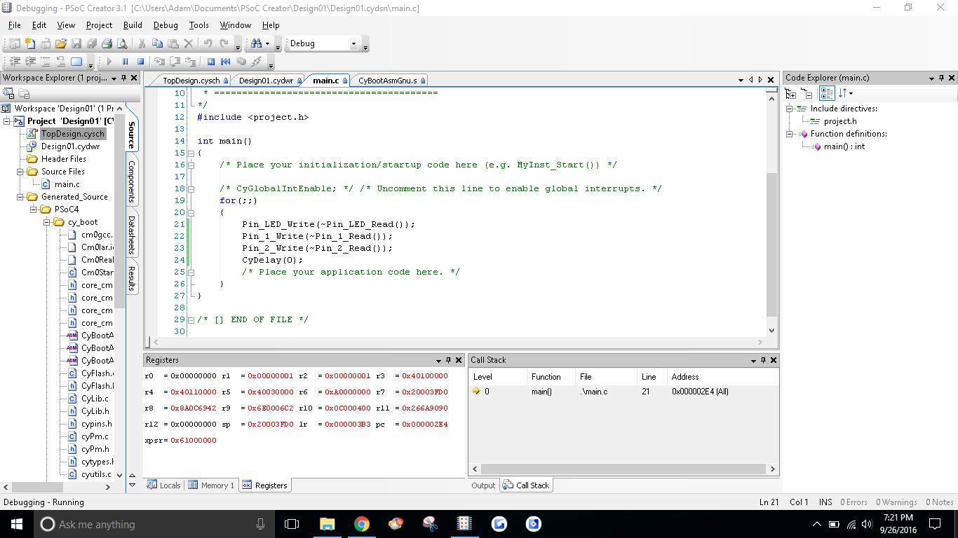

First, to get a white LED at all we added 2 new output pins, giving us a total of 3 variable pins, and assigned each of them to each one of the RGB pins, to create the white LED color. But before we could run it, we had to initialize the new components and adjust the CyDelay (the period) in the for-loop. We enabled the other two output diodes as shown in the code and changed the period from 1000ms to 0ms so that the LED would never oscillate as opposed to oscillating every second.

3. PWM HW Execution: Red LED



To exclude the software programming, we turned all the executable lines of code in the for-loop into comments by adding // at the start of each line. Now, we brought in a PWM component found in the Component Catalog in order to execute the program in the block diagram without and user-defined code, strictly hard wiring and pin assignments. We would need a clock for oscillation so we selected the “clock” component from the same directory as the PWM and Digital Output Pins used earlier in the project. We set the period to 1Hz so that we would get 1 cycle per second and we attached this clock to the clock input pin of the PWM. We attached the output pin that happened to be assigned to the Red LED (P2[6]) to the output port on the PWM_1 known as pwm2 and made sure the output component had the HW connection enabled before we would proceed to build, debug and run this program.

**CONCLUSION**

During this lab, we did not encounter many problems. The only two problems worth mentioning were figuring out how to assign all 3 of the of the RGB pinouts to give us the white LED color. We kept forgetting to disconnect the new pins from the Hardware to allow the firmware to regulate the LED. Another minor concern was as to why we were limited to which PWM block symbol to connect the Pin_LED to for the last additional exercise. We were able to successfully complete each additional exercise.